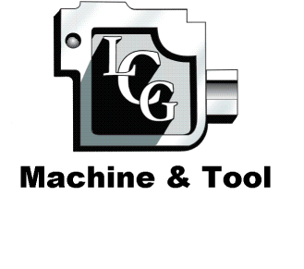

Capabilities Statement

COMPANY DESIGNATIONS

CAGE Code: 4HYL7
DUNS Number: 135156284
JCP Cert. Number: 0045623

Corporate Structure:
Veteran Owned
Small Business
ORCA Registration: Complete

NAICS CODES
332710 Machine Shops
332721 Precision Turned Product Manufacturing
333514 Special Die and Tool, Die Set, Jig,
And Fixtures
332116 Metal Stamping
333518 Other Metalworking Machinery
Manufacturing

SIC CODES

3469 Metal Stampings
3544 Special Die and Tool, Die Set, Jig, And
Fixtures

Company

L.C.G. Machine & Tool is an Ohio based company founded in 1998; the manufacturing plant and office are located in Columbus, Ohio. The company qualifies as a veteran owned small business.

Company Principals

Lowell Garrett: Has 38 years Experience in and Precision Machining, and 29 years in Tool & Die design and building.

Kevin Ferguson: Has 10 years experience in Tool & Die Making and Metal Stamping.

Key Product

L.C.G. Machine & Tool manufactures Precision Tooling and
Machined Parts

CUSTOMERS

- J.W Groves & Sons Inc.
- 2nd Tier U.S. Army Tank Automotive Command
- 3rd Tier Support Systems Associates, Inc
- 3rd Tier Naval Ships System Command

CAPABILITIES
CONTACT INFORMATION
L.C.G. Machine & Tool
2923 Grasmere Ave
Columbus, Ohio 43224-4155

Phone: 614-261-1651
Fax: 614-447-8051
E-Mail: sales@lcgmachine.com
Website: http://www.lcgmachine.com

- AutoCAD
- Tooling design & fabricating
- Small assemblies
- Metal Stampings
- Short run production parts
- Prototype
- Emergency Replacement Parts

